**NATIONAL UNIVERSITY OF COMPUTER AND EMERGING SCIENCE**



**Project Title: Digital Clock**

**Group Members:**

* **Ashmal Anis (19K-0305)**
* **Abdul Samad (19K-1396)**
* **Hasnain Somani (19K-0204)**

Contents

Introduction ……………………………………………………………………………..

Detailed Description of project ………………………………………………………….

What you have learnt from the project ………………………………………………….

Project Screenshot ……………………………………………………………………….

Circuit Diagram ………………………………………………………………………….

Conclusion ……………………………………………………………………………….

**Introduction**

Nowadays most people around the world are using an automatic digital clock in their daily use. We have chosen to create a digital clock because of its increased usage, and hence we want to create a digital clock to know how to understand digital clockwork. We know that time on the system, 60 seconds equals 1 minute and 60 minutes equals 1 hour. So the minute phase is taken by the second phase and the one hour phase taken by the minute phase. Each second and second section is designed to subtract the calculation from 00 to 59 and then to 00 and the hour section gives the calculation from 00 to 24 hours after which it repeats to 00. 59 cycles in the second's display, as a result, the minute's section increases its number by 1. Similarly, for each cycle of 00 to 59 minutes, a phase of an hour increases its frequency to 1. This way when the clock reaches 23hrs 59mins is 59. Each section is reset to 00 giving us a 00.00.00 display known as 0 hours. Now, without wasting any time we immediately get into discussions about our project.

**Detailed Description of project.**

The entire project of the digital clock can be divided into three major sections:

1. The second section (0-59)
2. Minute section (00:00-59:59)
3. Hours section (00:00:00-23:59:59)

Second Section:

In the first section, we use two counters ICs (7490) in a way that this site generates the output from 00-59 with the frequency of 1Hz. Then with the help of next following IC’s which is IC (7447) and seven-segment, it displays the count and both of these IC’s are common anode type. When all these necessary connections are done, we check the output of the circuit.

Minute Section:

In the Minute section, we repeat the same circuit of the second section, but here the output is from 00-59 with the frequency of 1Hz. Once the necessary connections are done, we check the outputs.

Hour Section:

Now in this section, we design the circuit in a manner that after a specific time interval, i.e. 23:59:59 it automatically sets the circuit to 00 indicating hours. Here the frequency is one pulse in 1 hour, and again after making necessary connections, we check the output.

Now once all these three sections are done, we assemble and combine the sections together in a common circuit and check the output of the final circuit and it should be our desired output.

**What you have learnt from the project?**

Through this project, which is constructing a digital clock, we have learned about the basic fundamental principles of the sequential logic circuit and how can we implement them to create a digital clock which can record or display time in an hour, minute, and second format. In addition, We have also learned about the operational functionalities of IC’s which are IC-7490 (Binary Decade Counter) and IC-7447 (BCD to Seven Segment Display) and their combinations with OR gates, resistors, batteries, and function generators which helps it to run efficiently. Moreover, We have also learned to apply all the basic functions of a digital clock that we see in daily life routines like alarm setting, alarm indicator/ alert, clock. We have also learned the module structure of the digital clock which consists of 4 sections, i.e. second section, Minute section, Hour section, and then assembling the three sections together and checking their output as well. Hence, we have not just learned about the working of IC’s, but were also able to grasp the knowledge of internal functions of the clock.

**Project Screenshot:**

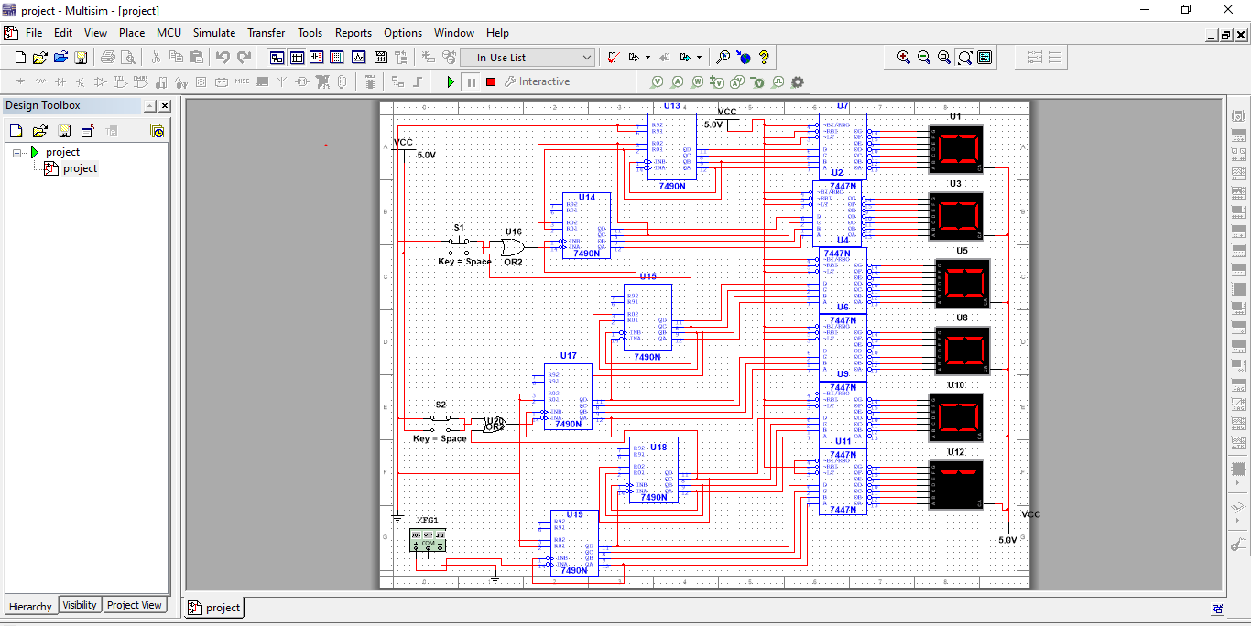

**Circuit Diagram:**

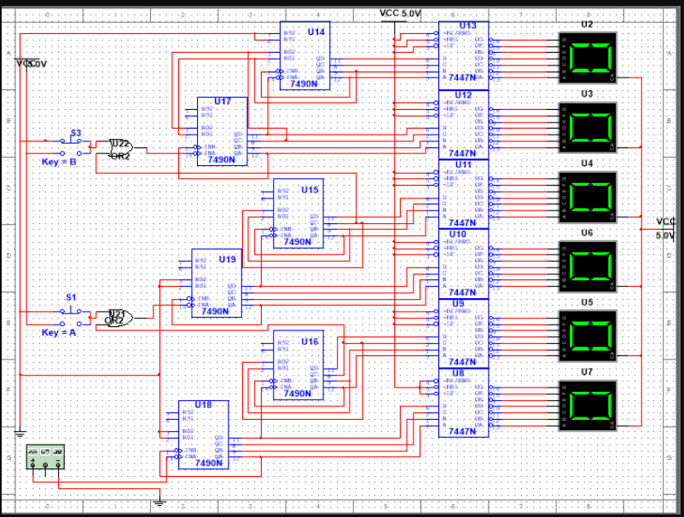

**Conclusion**

Digital electronics components were investigated in the project and Resistors, function generators, switches/keys, batteries, and a seven-segment display were combined to form a digital timer circuit. Different methods were analyzed to determine the best technique for creating an efficient timer until one was chosen and the circuit was designed. The chosen circuit was verified through final circuit which was formed after three module structure. This design was then implemented and modified through IC’s and seven segment displays and digital clock was constructed which shows the time in Hour/Minute/Second format.